U7 Blues
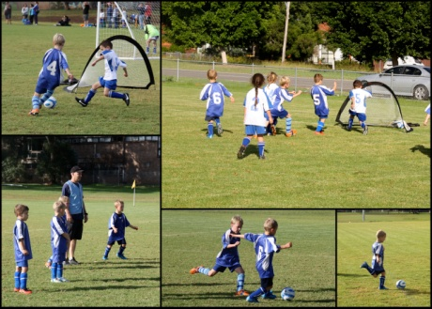
What a great start to the 2013 season!! The U7 blue team played magnificently for their 1st official game!
With all 4 boys using their new skills to pass, defend and score a multitude of goals. They helped each other, performed as a team and had FUN.
Thanks to all the parents as well, what a great encouragement! WELL DONE team and we are all looking forward to great 2013 season!

U9 Whites
With no training the team assembled early for a quick fine tune and team instructions. It took the team the whole of the first half to remember that space created time and opportunities. Strong first half performances from Liam Croker and Jayden Cook provided the team a strong core. The score was 3-3 at half time with goals to Aaron, Liam and Ethan.
A quick chat at half time and the kids went out and played in space, played down the edges and crossed the ball to the open player to come from 4-3 down to win the game 7-4. Second half goals to Jayden, Zac and 2 for Aaron cemented the win.
Man of the match to Aaron who scored a hat trick but Jayden cook and Ethan Ross had very strong performances.
Coaches Points
Jayden 3
Aaron 2
Ethan 1

U10 Blues
The Under 10 Blues played the Burragorang side on Saturday with marginally better results than in the trials. The first half started fairly even with the game flowing end to end and all of the team having a go. Kye Lawson showed promising signs of last years’ past glory with some good clearances from mid field. A stand out was Lachlan Sheens who took the teachings from the last two training sessions into the match and tried to get his teammates on board in working together and there were signs that this was starting to happen. Riley Keogh and Finlay Kirton playing as fullbacks were doing a great job assisting the Dylan May the first half goal keeper in repelling the waves of attack. However, after the first goal was conceded the heads started to drop and the structured fight back looked unlikely. The two goals scored by Burragorang in the first half came from relentless pressure with almost all of the players on the field in the United goal box attempting to score. The goals came from poor communication by the United team and incorrect positioning of players including where to stand as a goal keeper, so this is something that we will train on in the next few weeks.
United rotated the goal keepers at the break with Damien Pattinson manning the keepers role as he had down extremely well last year. The idea was to stop any more goals and create opportunities with Dylan May being released to play in midfield. Dylan was one of last year’s most effective attackers. Unfortunately the second half continued the way the first half. Burragorang scored 7 minutes in to the half and United were now 3-0 down. A poor clearance from a failed goal attempt saw a Burragorang player half volleyed a kick which hurdled our keeper on the bounce so now the lads were 4-0 down and playing with little to no structure at all. Shortly after the United lads created an opportunity at the other end whereby United took a shot but a Burragorang player hand balled in the goal square and the shot still went in. Quite rightly the referee pulled up the offence and awarded in favour of the United side. Unfortunately the referee gave a free kick two metres outside the goal box instead of a penalty and then allowed the 9 Burragorang players to stand on the goal square which gave United no chance to convert the opportunity. Another late goal was let in by United which is where the goal scoring finished up. United going down 5-0.

Overall a marginal improvement but still a long way from the standard that the boys need to achieve. Special mention for the improvement in the first half by Kye Lawson who got involved. William Bartlett had some strong efforts chasing balls down and tackling. Finlay Kirton played strongly chasing and out running opposition players but the two outstanding players were Riley Keogh and Lachlan Sheens. Riley for his defence in the first half in particular was outstanding. Lachlan Sheens was our player of the match demonstrating to his teammates what they have to do in order to be successful, if our lads had of taken his lead the score would have been quite different.

Fitness continues to be a problem with our lads as they are not use to the larger field and secondly, the lack of playing with structure. Too many players continue to play out of position and leave the defence with holes other attacking players are failing to remain forward so we have no one to take advantage of the opportunities we create when they come. So boys, look forward to a hard training session this week as your reward for your efforts.

AAL/5
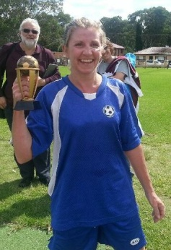
After being totally pumped to commence the season on a win, our dreams were quickly shattered when we realised we were playing the AAL1 mixed with U18s from Ingleburn. Team Awesome still put in their best effort stopping them from getting to double digits, even with the massive gap in the back line. We officially welcomed Bec to the team with her amazing goal for Ingleburn, and promptly moved her to striker. Suzs ability to be everywhere earned her the Travelling Trophy. Not only was our enormous defeat upsetting, we then received the news that our Coach had given up on us too and stepped down to focus on his role in the Exec. On behalf of Team Awesome, Neal thank you for all your work, time and patience with us we know we have come a long way under your guidance!
AA/5
Firstly I'd like to wish all teams from Under-6's to All-Age + M-League a successful 2013 season. Our side has managed to retain all 17 players from last year which is a great boost. While the squad depth helps us greatly during the year when some of us have Sunday commitments or our bodies are battered from injuries, this also provided a problem last Sunday when all 17 players enthusiastically showed up for the opening game, resulting in one of us missing out. Huge apologies go to Alex S, it won't happen again!
Our season opener saw us up against a determined Minto side who were hungrier for the win, beating us 3-2 in the dying minutes. Most of us would agree that this game has been a learning experience as we didn't know what to expect in division 5. Bring on next Sunday.
Goal Tally: Jeff T - 1, Alex T - 1
Round 1 KT26* winner: Matt H
(*For those wondering, the KT26 is exactly what you think it is: the old Dunlop shoe, famous in the 70's - 90's which is now a weekly award in our team for a standalone achievement worthy of recognition. Stay tuned for winners of this most prestigious award.)
ICU CUP & M-League
Firstly we as a squad would like to thank CUCSC for taking us aboard to represent the club in the 2013 season. The start of a new season, our first as a team in the M-League competition.

Round 1 saw us play against Bradbury with both ICU CUP & M-League sides scoring 2-1 victories.
The day started well for the lads in the ICU CUP with Luke Harrison scoring from wide out with what can only be described as a cross come a shot looping over the keepers head into the far corner of the net. Bradbury equalised early on in the 2nd half only for Joel Gordon to score a late winner after some brilliant lead up work from Mori Perez to seal our first win in the 2013 season.

Not to be out done the M-League boys came from behind after conceding an early goal in their match to a Bradbury counter attack, it took until about the 20th minute for the lads to find their groove playing some stylish football with some slick passing resulting in goals to Shane Deathe and Ben Mackay for a 2-1 lead at the half time interval. After the interval we had Bradbury on the ropes with some impressive passing but were unable to put a finished product on some good lead up work, on a number of occasions. The match ending as the first half did with CUCSC holding a 2-1 lead and making it a great result for the club collecting all 6 points from our first competitive fixture of the season.

U14/3 Show their respect to the Referees on Referees Weekend
