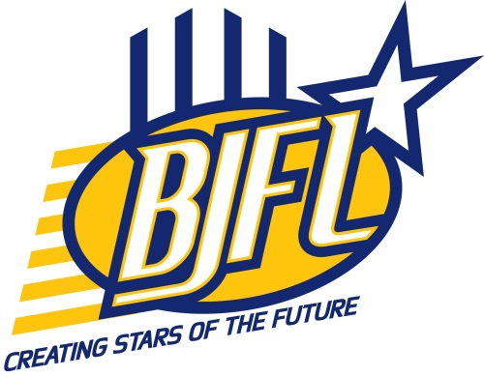
2014 BJFL Meeting Dates

January
February
March | 18th (P & S)
April
May | 13th (P & S)
June
July | 8th (P & S)
August |  | 19th (C & M)
September |  | 10th (Annual Dinner)
October | 14th (P & S)
November
December | 10th (AGM)
2014 BJFL Season Dates for U18 YG, U16, U14 & U12 Competitions
Month | Round | Friday | Saturday | Sunday
April |  | 18 | 19 | 20 | Easter
 | 1 | 25 | 26 | 27
May | 2 | 2 | 3 | 4
 | 3 | 9 | 10 | 11 | Mothers Day
 | 4 | 16 | 17 | 18 | Moama Carnival 18th
 | 5 | 23 | 24 | 25
May/June | 6 | 30 | 31 | 1 | Shepparton Interleague TBC
 | 7 | 6 | 7 | 8 | Queens Birthday Long Weekend
 | 8 | 13 | 14 | 15 | Ballarat Interleague Confirmed 14th
 | 9 | 20 | 21 | 22
 | 10 | 27 | 28 | 29 | Ist Weekend of School Holiday
July | Bye | 4 | 5 | 6 | Middle weekend Of School Holidays
 | 11 | 11 | 12 | 13 | 3rd Weekend of School Holidays
 | 12 | 18 | 19 | 20
 | 13 | 25 | 26 | 27
August | 14 | 1 | 2 | 3
 | 15 | 8 | 9 | 10
 | 16 | 15 | 16 | 17
 | Finals W1 | 22 | 23 | 24
 | Finals W 2 | 29 | 30 | 31
September | Finals W 3 | 5 | 6 | 7 | Fathers Day
 | Finals W 4 | 12 | 13 | 14 | Grand Finals
 |  | 19 | 20 | 21 | Ist Weekend of School Holiday  BFNL Grandfinal
KEY: P - president’s S - secretary’s C - coaches M - team managers

