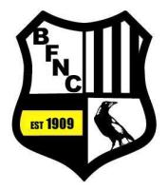

Michael (Mick) Leenheers
Induction into
Belgrave Football Netball Club
Hall of Fame

Last year 15 Life Members of the Belgrave Football Netball Club proposed Mick for induction into the Hall of Fame. This was announced at the vote count and confirmed at the 2015 AGM.
It is proposed to hold a function to officially welcome Mick into the Hall of Fame.
The function will be held at the club on Friday Night the 26th of August 2016 at 7.00pm (night before our last game of the season) . Come along and be part of the recognition of Mick for his efforts at the football club for many years. It will culminate in Mick being officially inducted into the Hall of Fame.
I would invite Hall of Fame Members, Life Members, current / past players & officials, and friends and family of Mick to come along to ensure a great night to celebrate Mick’s achievements and catch up with each other.
Finger food provided and drinks will be at reduced bar prices. Some complimentary red and white wine and beer will be available early in the night.

Please RSVP by email :-hallfame2016@gmail.com
or see Frank Scammell or Bernie Weisgerber

