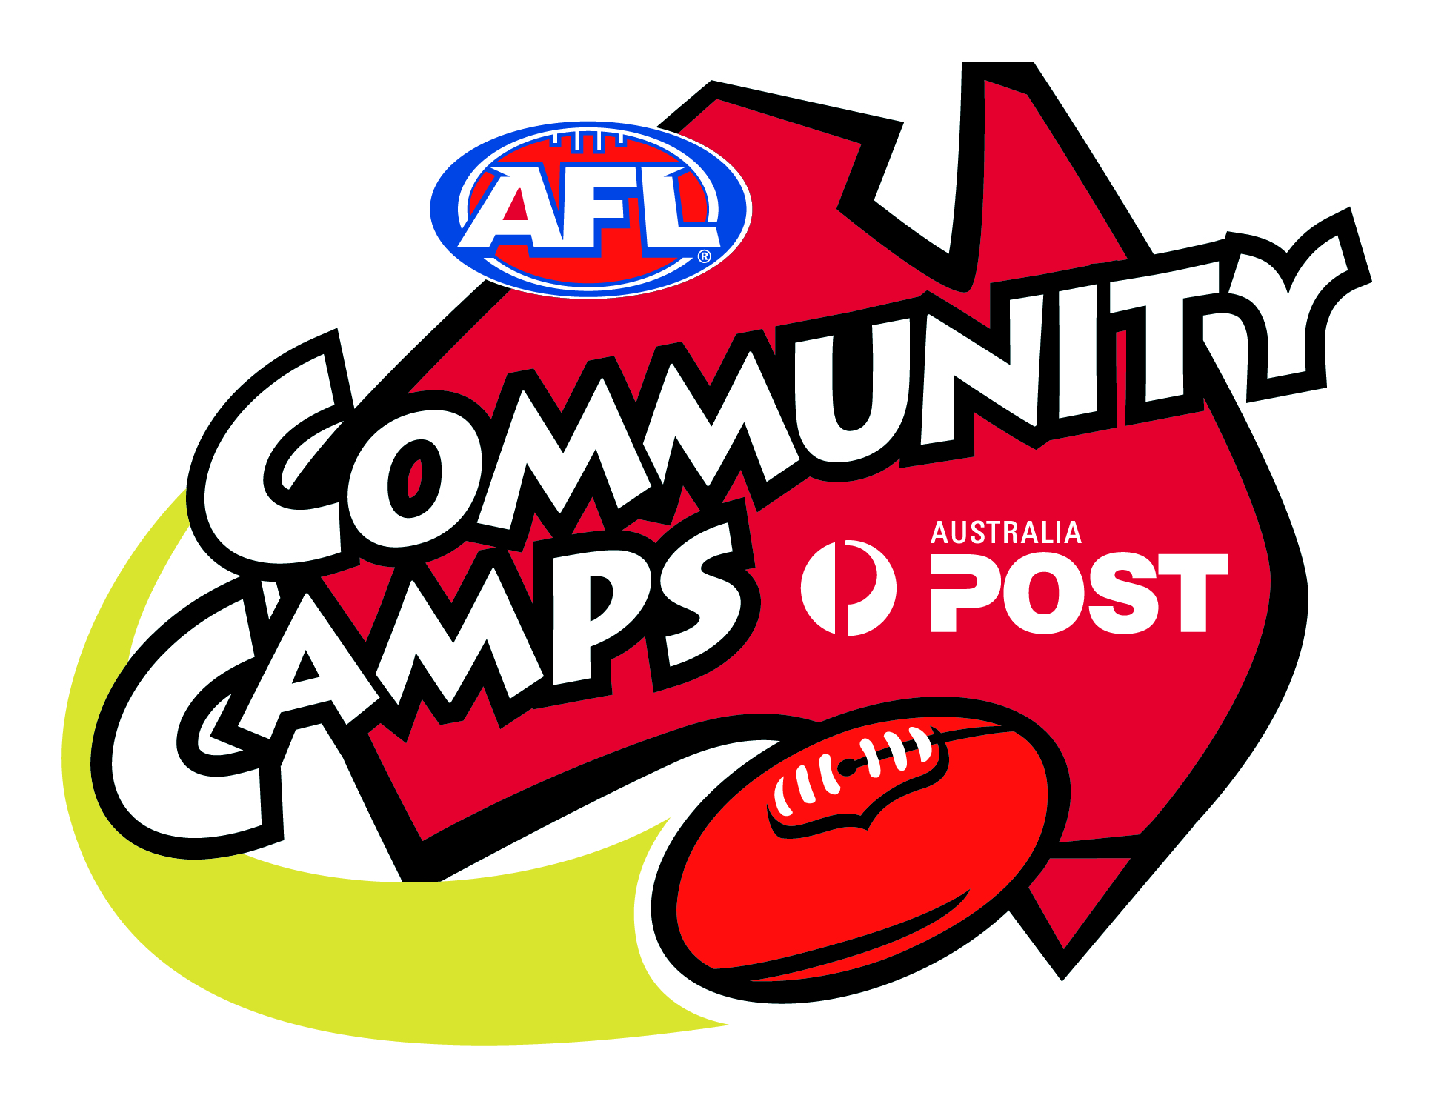

AFL Football Coaches Clinic
- Carlton Football Club
- Thursday 7th February 2013
- Queen Elizabeth Oval (QEO)
(South Bendigo Club Rooms)
- 5.30 – 6.30pm
- Presentation by Carlton FC Assistant Coaches
- Free activity
Open to any Coach
Come along and support your local Coaches Association and learn for the season ahead

