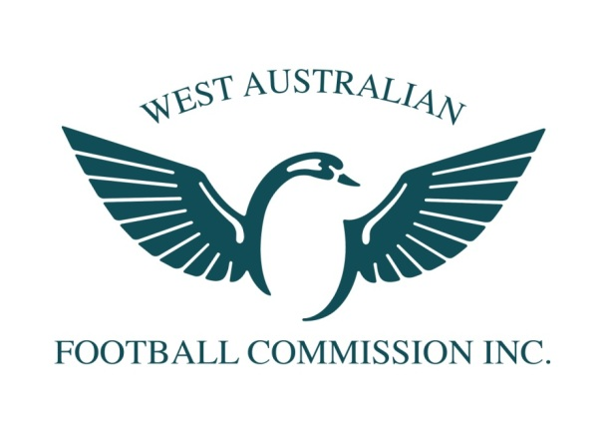
2014 WAFC Female Football Talent Academy
Female Football Talent Academy: Manager

POSITION TITLE: Female Football Talent Academy: Manager (16-18yrs)

DATE ASSUMED POSITION: November 2013

REQUIREMENTS: 1 x 2 hour Saturday morning session per month + 2 representative games

EXPECTED DATE TO CEASE POSITION: November 2015

KEY FOCUS OF THE ORGANISATION

To enhance and promote Australian Football throughout the community, encourage greater levels of participation for young females, enjoyment and commitment by individuals, community groups, business and government

KEY FOCUS OF THIS POSITION

- To create an elite developmental environment that is conducive to both learning and enjoyment for young female football players
- Contribute to the development of skills, physical attributes, football knowledge, personal growth and self-esteem of all players
- Establish, implement and coordinate appropriate training programs that maximises the development of all players
- Lead and influence all players and staff in a positive manner.

MANAGER REQUIREMENTS

Planning and Implementing Training Sessions

- Attend training sessions
- Where required be responsible for training facilities general lock up, maintenance of equipment and distribution of gear
- Distribute handouts/information pertaining to program
- Contact players re: change of venues, times, training requirements
- Maintain accurate player profiles, contact details, medical forms
- Keep accurate record of training attendance
- Develop close rapport with playing group and act as a liaison between players and parents as needed
- Effectively liaise with Assistant Coach, State Coaches and WAFC Female High Performance Manager
- Ability to report and contribute to the planning review process at the conclusion of the program in conjunction with all coaches

Human Resources

- Encouragement and support of players individual development
- Provide feedback to all players where relevant
- Report to the Head Coach and WAFC Female High Performance Manager on all matters pertaining to the program and player welfare
- Liaise closely with the Head Coach on all matters pertaining to the program and player welfare
- Assist in the mentoring of the playing group
- Demonstrate leadership and feedback to all players, parents and coaches
- Work cohesively with other Assistant Coaches and State Coaches
- Possess sound conflict resolution skills

Information, Communication and Management

- Provision of accurate and timely feedback (verbal, written, visual) to all players/staff (including medical and support staff)
- Appropriate instructions to players at training sessions and representative games
- Collate player/staff clothing sizes
- Liaise effectively with all coaching and support staff
- Contribute to reviews with the support of all staff

Talent ID and Selection

- Liaise with selectors and Assistant Coaches on matters of team/ squad selection & talent identification
- Liaise with the Female High Performance Manager re: the new Talent Academy

Football Knowledge
- Demonstrate some knowledge of coaching techniques / strategies
- Sound knowledge of WAFC Talent Pathways and programs
- Commitment to ongoing personal development in the area of coach education

Public Relations

- Attend all functions as requested by the WAFC relating to the WA State U 18 Youth Girls Team
- Communicate with the Female High Performance Manager when required
- The Team Manager shall wear approved WAFC State apparel for all training sessions, team or representative functions and matches.
- Attend the Lap of Honour to represent the team at the WAFL Grand Final in September

Personal Traits
- Ability to demonstrate empathy for players and staff
- Ability to demonstrate honesty and integrity in all roles within the Talent Academy
- Ability to motivate through a variety of mediums
- Ability to facilitate players and/ or staff personal development
- Highly developed and proven written, verbal and visual interpersonal skills
- Highly organised
- Meticulous organisation

SELECTION CRITERIA REQUIRED:
1. Demonstrated high levels of organisational skills on multiple levels
2. Demonstrated knowledge, involvement and understanding of talent development programs
3. Highly developed verbal and written communication skills
4. Demonstrated ability to formulate and communicate sequential programming and planning skills
5. Demonstrated ability to nurture talented athletes
6. Demonstrated ability to develop high levels of team spirit and unity
7. Hold a current Working With Children Check

Please note - current State Female Coaching staff are not permitted to apply for this position. Applications should include a 1 page covering letter, a relevant CV and address the 7 selection criteria. Applications not fulfilling these requirements will not be considered. Questions or queries may be directed to Alison Moore on 0430868145 or amoore@wafc.com.au

All applications should be received by 5.00pm Wednesday 13/11/2013 and addressed to; Alison Moore, WAFC Female High Performance Manager, P.O. Box 275, Subiaco WA 6904 Email: amoore@wafc.com.au

