Winter Season Handbook
2013
North Harbour Football & Sports Club
Albany United Football Club
1/12/2013

2013 Winter Season General Information

Press ctrl & click on page number to go to section

Season dates 2
Registering Options 2
Payment Options 6
Fees 8
Midgets 9
Junior 10
Youth 11
Seniors 12
Muster Day/Team Selections 13
Existing teams 13
Strips 14
Coaching 15
Managers 15
Match Officials 15
Coaches Meetings 15
Rules of the game 15
Results 16
Substitutions 16
Trainings 17
Ricki Herbert Football Academy 18
Tournaments 18
Cancellations 18
Changes 18
Sponsors 18
Team Photos 19
School Holiday Programmes/Junior Kicks 19
Safety 19
Summer Soccer 19
Field Information 20
Contact information 21

Season dates

The winter football season generally runs from the 1st Saturday in April to the last Saturday in August. This can vary depending on school holidays, Easter break etc. For social grades there are generally no games during the middle weekend of the school holidays. We will endeavour to have a club calendar kept up-to-date on the website.

Registering Options

Online
- Visit the website www.albanyunited.org. You can go to the right hand side where it says Register now and click on link or hover over the “Winter 2013” tab located in the red bar.
- From the drop down menu click on the Midget or Junior sub menus for “Online Registrations”.
- Then click on the Registration Form link
- Follow the online instructions, some screen shots are below to help

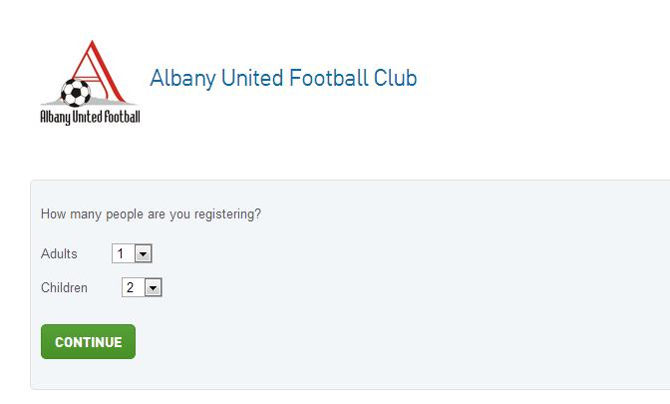

- Here is where you enter how many people from your family are registering. The adult entry will always be processed first and so on.
- NOTE: If possible register the whole family in one go – it saves time for yourself and us.

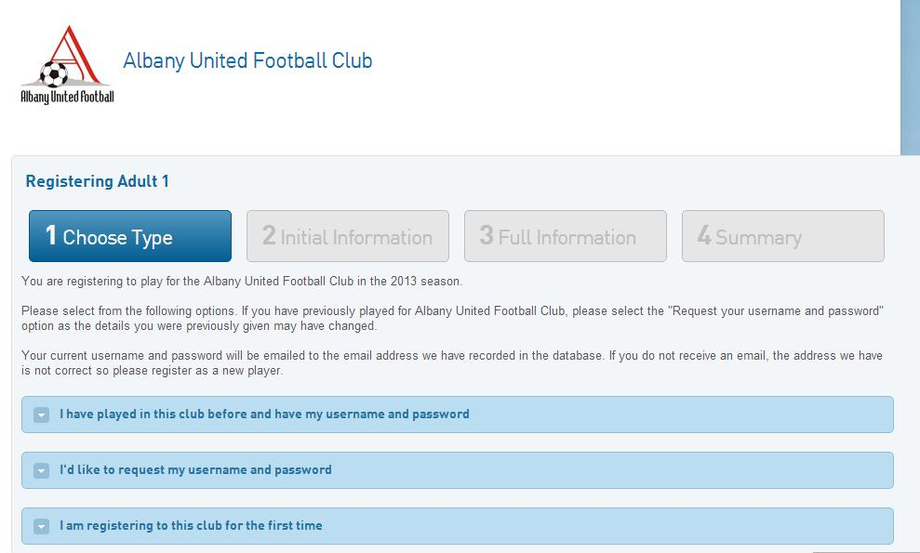
- This page is where you are registering your first member. If you have played before and have your username and password you click first box and you will see below.

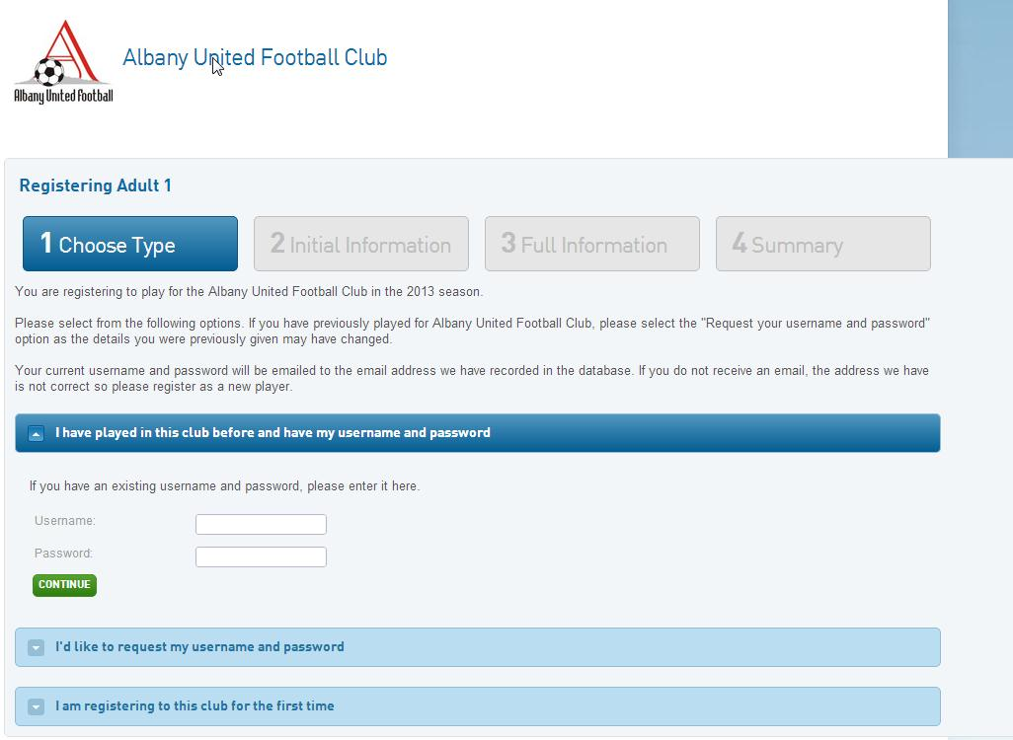

- You would enter your username and password now.
- If you have played before but don’t have username and password then you would click on the second box and would see below. You would enter your email address and it will be sent to you. Note: you must enter the email address you used to register the previous year. If you are no longer using that email address register as a first time person.

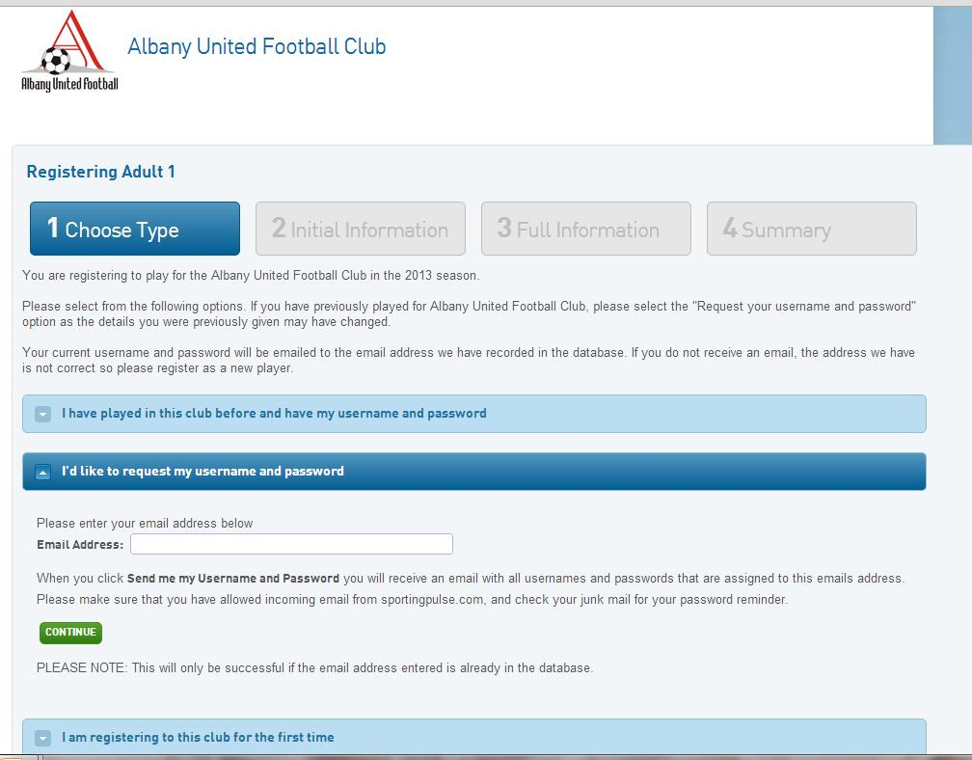

- If you are first time member click on last box and you would see below

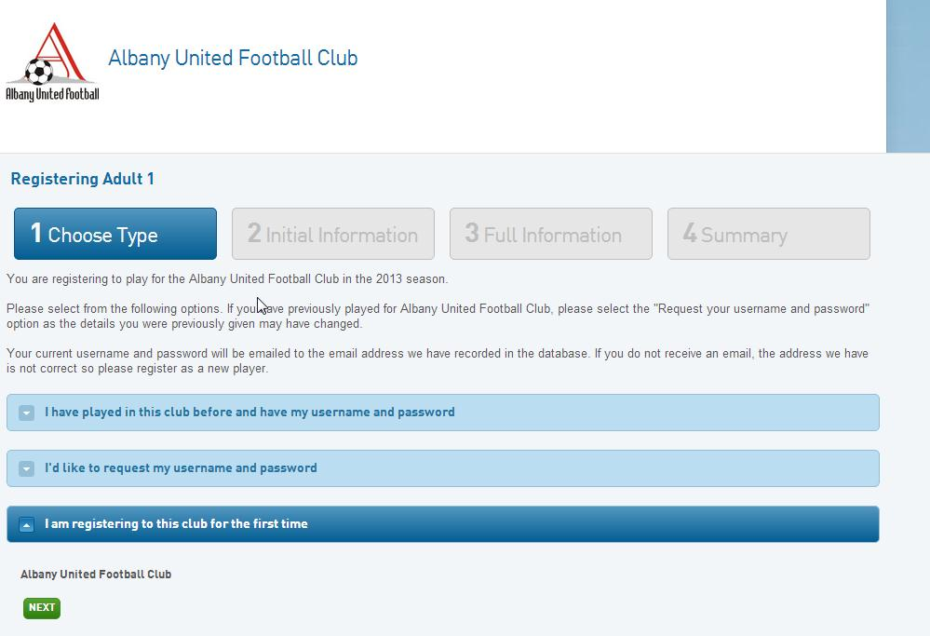

- Click next and go to the registration screen (below)

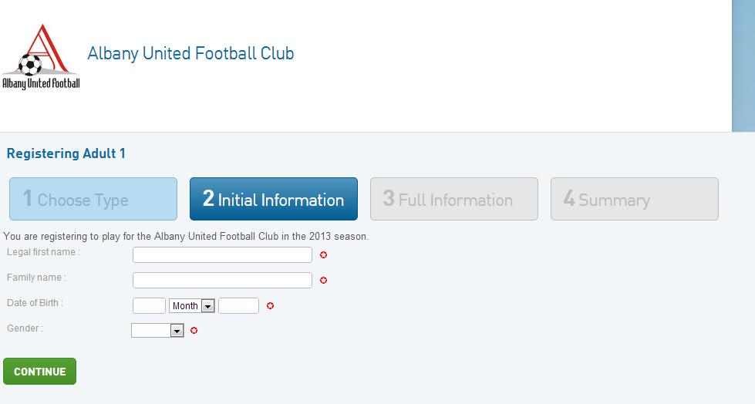

- Click on continue after you’ve entered the initial information and keep registering.
- At the end you will click on payment options.

Paper
- If you cannot register online please email admin@albanyunited.org to request a paper registration form. Please ensure the subject of the email is “Requesting a paper rego form”
- The completed registration form can be emailed to admin@albanyunited.org with the subject heading, “Completed rego form”, or faxed to 09 415 8772 or posted to North Harbour Football and Sports Club, PO Box 302 764, North Harbour or drop it into the club during office hours at Jack Hinton Drive, Albany

REGISTRATIONS FOR 2013 SHOULD START AROUND BEGINNING OF JANUARY. KEEP AN EYE OUT IN YOUR LOCAL PAPERS, OUR WEBSITE AND SIGNS AROUND THE AREA.

Payment Options

We regard a member of Albany United FC as a person who has fully paid their fees and fully registered in 2013 via the online registration process or manually sent in their registration form to the club.

Online
- Payment can be done online at the end of the online registration process via credit card. Please note that a 3.9% processing fee is charged for online payments.

At the completion of your registration online, you will be presented with a few options to select from. Please select the correct option to ensure your registration is processed correctly.

Example: For 8th Grade registrations, please select the 8th Grade payment option.

You will then be given a username and password (we suggest you note down this information–this is the information required to access your registration)

You will then be prompted to pay your registration fee online. Choose this option and the appropriate registration fee (and 3.9% fee) will now show on screen.

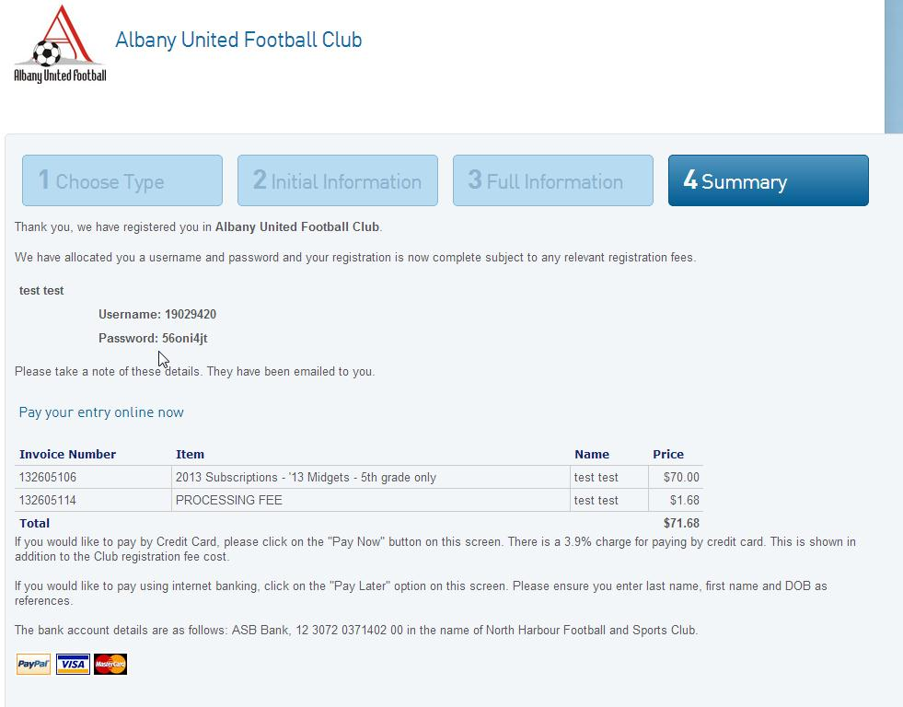

Click “Pay Now” and complete the necessary fields (See below screen shot)

If you wish to pay by Internet banking then Click “Click here to choose to pay later” and pay via Internet banking (information below)

Internet banking
- Payment can be done via Direct Credit into the clubs bank account, ASB 12-3072-0371402-00.

Please clearly label your payment with the members’ full name and DOB.

Note: Do not use the registration number from the online registration as this will not correspond to your direct credit payment. This reference number from the online registration is for admin use only.

Cheque
- Please make these out to North Harbour Football and Sports Club.

These can be posted to PO Box 302 764, North Harbour

Note: These can be posted to us or dropped into the office.

Cash
- This can be dropped into the club during office hours.

Note: Please try to have exact cash as we do not carry cash on the premises.

Fees

The fees structure for 2013 will be:
Midgets | 5th grade only | $70.00
Midgets | 6th, 7th & 8th grade | $125.00
Junior & Youth | 9th grade to U17’s | $170.00
U19’s & Senior Student | Must show student ID | $230.00
Senior Men’s & Over 35’s |  | $285.00
Ladies |  | $250.00

Included in the fees is the NZ Football fee, Northern Football Federation fee, running costs of the club.

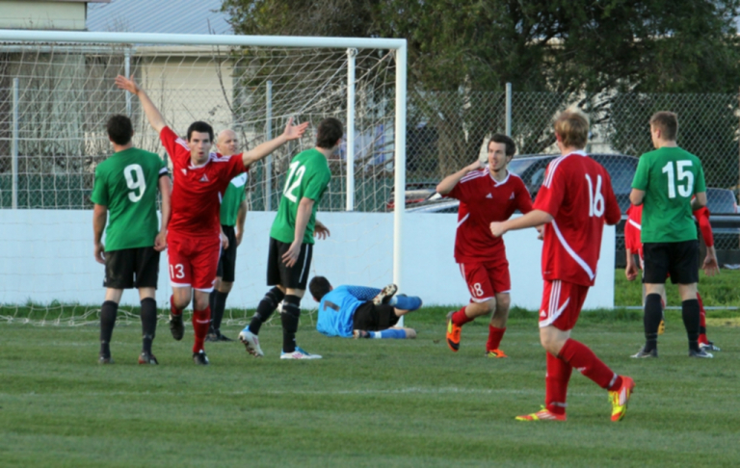

Midgets

We regard these as our 5th to 8th Grade kids.

We accept kids from 4 ½ years as long as they are turning 5 years of age during this season.

They are placed into teams according to age.

Example of Grades:
Turning 5 years of age before the end of 2013, you will be considered a 5th grader,
Turning 6 years of age before the end of 2013, you will be considered a 6th grader.

Movement between grades is possible for 5th to 8th Grade only, subject to discussion and approval from the club.

The Midget Competition is administered and run by Albany United FC. Competition draws will be hosted on the club website. Depending on availability of fields and weather, playing times are:

Grade | Warm up/training exercise | Kick off  Game 1 | Kick off  Game 2
5th & 6th | 8am | 8.10am | 8.30am
7th & 8th | 8.50am | 9am | 9.25am

All Midget games are played at our home ground, Rosedale Park, Jack Hinton Drive, Albany.

2012 saw the Whole of Football Plan being installed in all clubs in New Zealand. So there were a few changes from previous year’s set up. Please also check the website for information regarding this.

5th & 6th Grade (First Kicks)
- 4 v 4 with no goalkeepers
- Play on a reduced field measuring approximately 30m by 20m with small moveable goals.
- Two 15 minute games per play day

7th and 8th Grade (Fun Football)
- 5 v 5 with no goalkeepers
- Play on a reduced field measuring approximately 30m by 20m with small moveable goals.
- Two 20 minute games per playing day

- Young players must enjoy their participation in the game in order to develop their skills. Fewer numbers of players involved in any game leads to more touches of the ball and consequently earlier development of ball skills for players at an early stage.
- Coaches are asked to ensure that all players receive equal playing time.

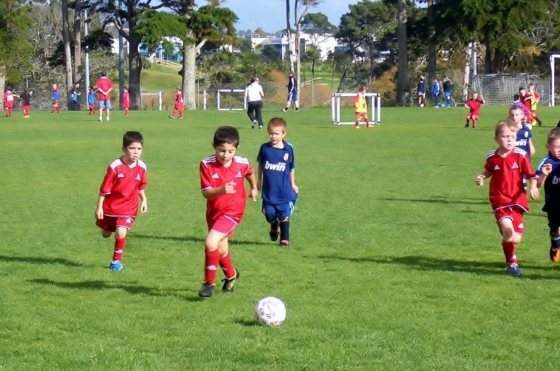

Junior

We regard this as our 9th to 12th Grade kids.

All juniors who are not already in a fixed team and those who wish to be looked at for the top teams of their grade are required to attend the Muster Day on Sunday, February 24 2013 (See Muster Day 2013 for more information). There will be committee members and coaches who will look at all players and place them into the correct teams based on ability. If you are looking at only social teams and wish to be placed with friends only please let the club know previously to the Muster Day.

Example of Grades:
Turning 10 years of age before the end of 2013 you will be considered a 10th grader.

The competition is run by the Northern Football Federation.

Games are played on various fields across the North Shore and West Auckland as announced by the Northern Football Federation. Please see their website, www.northernfootballfederation.org.nz for detailed maps and ground locations

9th Grade and 10th Grade (Mini Football)
- 7 v 7 (including a goalkeeper).
- Play two games per playing day
- Play on a field approximately 55 by 35 metres.

11th Grade and 12th Grade (Mini Football)
- 9 v 9 (including a goalkeeper)
- Play on a field approximately 70 by 50 metres
- The club will supply each 11th Grade and 12th Grade team with goal nets and net pegs at the beginning of the season; these must be returned to the club after the last game.

Coaches are asked to ensure that all players receive equal playing time.

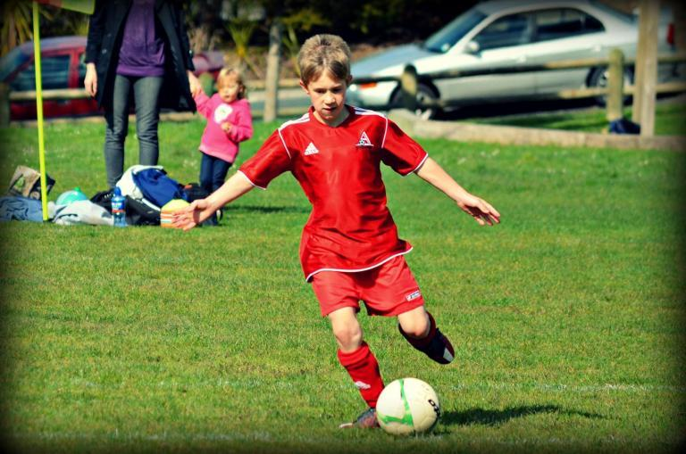

Youth

We regard this as our 13th Grade to Under 17s Grade kids.

All Youth who are not already in a fixed team and those who wish to be looked at for the top teams of their grade are required to attend the Muster Day on Sunday, February 24th 2013 (See Muster Day 2013 for more information). There will be committee members and coaches who will look at all players and place them into the correct teams based on ability. If you are looking at only social teams and wish to be placed with friends only please let the club know previously to the Muster Day.

Example of Grades:
Turning 17 years of age before the end of 2012 you will be considered as an U17.
Turning 18 years of age before the end of 2012 you will be considered as an U19.

The competition is run by the Northern Football Federation.

Games are played on various fields across the North Shore and West Auckland as announced by the Northern Football Federation. Please see their website, www.northernfootballfederation.org.nz for detailed maps and ground locations

13th Grade to Under 17s
- Play on a full size field with full size goals.
- The team sizes are roughly 14 or 16. There are 11 players on the field at a time including a goalkeeper.

Seniors

U19’s
You need to be 19 or under during 2013 to be eligible for U19s.
- Trialling and training dates for U19’s will be on the website when finalised.

Open Men
These grades run from 1st division to 7th division

Ladies
These grades run from 1st division to 3rd division

Over 35’s
You need to be 35 or over to be eligible for Over 35’s

Over 40’s
You need to be 40 or over to be eligible for Over 40’s.

Note: The open Men, Ladies, Over 35’s and Over 40’s are often established teams that have played at the club for several years. If you are interested in joining a senior team or registering a full senior team please contact the office on admin@albanyunited.org

Muster Day/Team Selections

This will be held at Rosedale Park on Sunday 24th February. All Junior and Youth players wishing to trial for the top 2 teams and ALL PLAYERS needing to be put into a team are required to attend. If you cannot make this day please let the club know ASAP. The times and associated information will be hosted on the club website.

Committee members and associated coaches will assess players attending the muster day and help put players into teams.

Existing teams

Midgets
- If you are returning from last year please send your full team list with coaches and managers details to the office ASAP after registration starts and no later than 10th March (the official team form will be on the website for you to use once registrations are open)
- This assists us in getting the draw sorted quickly.
- If you are short of players please let the office know. We often have single registrations that may be from the same school or area as your team and we can get their details to you quickly.

Junior/Youth
- If you are a returning team from last year please send your full team list with coaches and managers details to the office by 8th March 2013 (the official team form will be on the website for you to use once registrations are open)
- The Northern Football Federation have a deadline for clubs’ to enrol its’ teams by, to enable them to book fields and set up the competition draws.

Seniors
- Please forward the office your full team list along with coaches and managers’ details to the office by 4th March 2013 (the official team form will be on the website for you to use once registrations are open)
- The Northern Football Federation have a deadline for clubs’ to enrol its’ teams by, to enable them to book fields and set up the competition draws.
- Team fees are available provided they are paid in full and in one lump sum, please contact the Senior Convenor for more information.

Strips

Midget
- All Midgets are required to wear the reversible shirts purchased prior to 2012 season or the new Adidas Midget Strip, which can be purchased online from Football Central. The link is on our website under Uniforms On-line.
- All midgets need to have red shorts, red socks, football boots, shin pads and a drink bottle.
- Sponsored strips can be worn provided they meet the club criteria (contracts). Please contact the office for more information.
- Midget coaches will be provided with a gear bag which will be handed out at the Coaches meetings, which all coaches are required to attend. This will be held late March/early April; watch the website for more information.

Junior/Youth
- All Juniors and Youth are given shirts from the club.
- These are handed out at the coaches meetings, which all coaches are required to attend. This will be held late March/early April; watch the website for more information.
- All Juniors and Youth need to have red shorts, red socks, football boots and shin pads. We recommend also having a drink bottle.
- Sponsored strips can be worn provided they meet the club criteria (contracts). Please contact the office for more information.

Senior
- All Senior teams are given shirts from the club.
- These will be handed out at the coaches meetings, which all coaches and/or managers are required to attend. This is usually around the end of March; watch the website for more information.
- All seniors also need to have red shorts, red socks, football boots and shin pads.
- Sponsored strips can be worn provided they meet the club criteria (contracts). Please contact the Senior Convenor for more information.

Coaching

Coaches are required to take one training a week and to be present at games. A coaches meeting will be held before the season starts. All teams must have a coach and manager and someone who will referee half the game (this is often the coach in the midget’s league but usually someone else junior and up). For coaching information please contact our Coaching Development Officer Mason Ellington on cdo@albanyunited.org.

Remember that often the coach of your child’s team is a parent and or volunteer to the club, so please support them as much as you can.

Managers

Each team is required to have a manager. This person will be in charge of running the team, allowing the coach to freely teach, inspire and mature the players’ football without the need to worry about paperwork. This person will be sole communicator to and from the club and keep the team updated with information on cancellations, photos, prizegivings etc. and to ensure that the team list is up to date and has been sent to the office before the required time.

Match Officials

Teams from Midgets to Senior Men’s (including Ladies, Over 35’s and Over 40’s) must supply a referee for at least half of the game. Division 1 (including Metro teams) and up are often supplied with a referee from the Northern Football Federation referees pool. Regardless of the ability, experience or errors you deem the referee has made, it is not alright to abuse the officials.

Coaches Meetings

We will endeavour to have regular monthly coaches meetings throughout the year. The first will be prior to the start of the season to hand out gear and make sure all coaches have all the information they need for the season. These meetings are compulsory for all coaches to attend. Whilst we can’t cater for everyone’s schedule, we will try to have these at suitable times to ensure maximum turn out. The website will be updated with information and emailed to the coaches and managers.

Rules of the game

The standard rules of the game along with updates for the 2013 season will be available on the website under 2013 Winter Season/Midgets/Rules. Midget coaches will also be handed these rules prior to the start of the season.

Rules differ from grade to grade than to those of standard football rules and we encourage all parents/players/coaches/managers to familiarize themselves with these before the season starts.

Results

Midgets
- Due to the new Whole of Football Plan that was run last year, no scores need to be handed in at the end of the game as midgets are non competitive.

Junior/Youth
- Results must be texted through to the Albany United FC results officer on 021 0289 8545.
- This contact information will be provided to each coach/manager prior to the start of the season.
- The results are passed onto the Northern Football Federation, who runs the competition. It’s vital that the game result is sent through directly after your game.
Seniors
- Results must be phoned or texted through to the Northern Football Federation results line for every home game.
- Team cards must also be completed for every game and put into the blue box near the bar after the game. 1st div teams only must get there team cards to Northern Football Federation no more than 3 days after game day. You can post these in yourselves or leave them at the club after your game in the blue box near the bar.
- Un-notified results and late cards result in fines for the team and possible lost match points for the team concerned. All fines will be invoiced to the team by the club on behalf of the Northern Football Federation, an administration fee charged.
- Team Cards are available from behind the bar.
- The results are posted onto the Northern Football Federation website. It’s vital that the game result is sent through directly after your game (before 5pm of the game day.

Substitutions

Midgets
- Rolling subs are used in midget football and any number of changes can be made.
- Changes should be made during a stoppage in play.
- Coaches should ensure that every child enjoys the maximum available playing time in each game.

Junior/Youth
- Rolling subs are used, however to a maximum of 3 players only.
- Changes should be made during a stoppage in play.
- Coaches should ensure that every child enjoys the maximum available playing time in each game.

Under 19’s
- Rolling subs are used, however to a maximum of 3 players only.
- Changes should be made during a stoppage in play

Senior Men’s Division 2 and below
- Rolling subs are used, however to a maximum of 3 players only.
- Changes should be made during a stoppage in play.

Senior Ladies Division 2 and below
- Rolling subs are used, however to a maximum of 3 players only.
- Changes should be made during a stoppage in play.
Over 35’s and Over 40’s
- Rolling subs are used, however to a maximum of 3 players only.
- Changes should be made during a stoppage in play.

Trainings

Training is run differently for each team, to suit the coach’s availability.

Midget/Junior/Youth
- Have use of the fields at Rosedale Park, Rosedale South and Albany Domain on Monday to Thursday nights until 6pm.
- The number one field at Rosedale Park is not available for training and teams should avoid using worn areas of the fields, such as goal areas and centre circles.
- Any training sessions which involve repetitive running over the same area, must be done off any playing field.
- To accommodate as many teams as possible, training should be held on an area approx the size of a ¼ field.
- Training ideas and topics will be made available to coaches and parents at the monthly coaches meetings. With the new Whole of Football Plan there will be information handed out to coaches with different training sessions on cards for coaches of Midgets to use.

Seniors
- Have use of the fields at Rosedale Park, Rosedale South and Albany Domain on Monday to Thursday nights from 6pm onwards.
- At Rosedale Park, seniors are to use the designated training field.
- A booking system will be in places during 2011 for senior teams wishing to train. Please contact the Senior Convener to book your training time

Ricki Herbert Football Academy

We are happy to be able to offer term courses and holidays programmes through Ricki Herbert Football Academy again this year. After a very successful year we are hoping for even more players to use this avenue. Courses are broken up into age groups, usually, 7/8, 9/10, 11/12, 13/14. Term courses are usually run over 6 or 8 weeks and holidays programmes are usually run over 3 days during the school holidays. For all information on dates and times go to the website www.albanyunited.org or www.rickiherbert.co.nz.

Tournaments

We will be running tournaments throughout the year across all Midget and Junior grades. Approximate dates are:

- 5th and 6th grade: Sunday 5th May 2013
- 7th and 8th grade: Sunday 26th May 2013
- 9th grade: Sunday 9th June 2013
- 10th grade: Sunday 23rd June 2013
- 11th and 12th grade: Sunday 28th July 2013

More information when finalized will be sent out to all coaches via the coaching development officer and also on our website.

Cancellations

Use of the grounds is controlled by the council and dependant on weather conditions, the use of the grounds can be limited at various times. In the event of cancellations a message will be left on the website and if a message will be left on the club answer phone AFTER 6.30am on Saturday morning confirming the cancellation. Where possible the coaches/managers will be informed via text and/or email.

Please note for 9th grade and above that fixtures are date controlled - in the event of cancellations games will be added to the end of the round.

Changes

Due to council field restrictions or weather conditions changes can occur. For 9th grade and above these are emailed to the administrator late Friday night from the Northern Football Federation. We will add this information to the club website and email and/or text the coaches/managers affected.

Note: for midgets we will try to let you know as soon as we know if your opposition can’t field a team

Sponsors

With the size of the club we receive a lot of local and media attention and can offer sponsors great opportunities to support our club and receive benefits to their business. There are a number of opportunities available for sponsors, ranging from supporting the youngest midget teams right through to our senior teams. Our sponsor’s league provides sponsors with a fun opportunity to be part of the club. Inquiries from any potential sponsors are always welcome – please contact the club for further information.

Team Photos

Team photos will be held on 9th and 10th July 2013. We would love for the entire club to be part of this. Even if you don’t wish to purchase a photo, the club would like to have a record of all teams for the year. We have a booking system and all coaches/managers will be emailed when it is time to book a space.

If you wish to purchase a photo, they must be purchased on the night they are taken. Inserts can be accepted however this is a fee which must also be paid for on the night. A link will then be sent to you to assist you upload the photo you want inserted. All photos will be delivered back to the club rooms and will be handed out at the prizegivings.

A form must be completed on the night and a receipt will be issued if required. The forms are sent to all coaches/managers before the night for distribution to all team members. Forms will be available on the website for download.

People who wish to order photos after the order day, will need to order these through the club and will attract a slightly higher cost. In the past the cost for photos (purchased on the night it was taken) has been $15 each however we haven’t been told the official price for 2013. We do however expect them to be around the same price

School Holiday Programmes/Junior Kicks

We ran a couple of these in 2012 for the younger age groups that Ricki Herbert Football Academy don’t offer too. These are called Junior Kicks and they were very popular. We will have more information when it comes to hand on the website.

Safety

All players must wear shin pads at all times when playing and ensure that they are covered entirely by their socks. Players should not wear any jewellery – this includes earrings, rings, bracelets and watches.

Summer Soccer

We have successfully held a Summer Soccer programme for 3 seasons, with 2011-2012 being our biggest year. We accept team registrations only for Summer Soccer but we do have a database of singles in case teams are short. Registrations usually start at the end of the winter season. Registration forms will be available on the club website. Please be aware that we have limited spaces in each grade so it is on a first in first served basis. If you think you will be putting a team in, please email the office and we will put a spot aside for you. We will hold this spot only up to the registration end date, if you have not registered and paid by this date your spot will be taken up by people on the waiting list. More information regarding Summer Soccer is also on the website.

Field Information

Rosedale North Park – Main fields and clubrooms

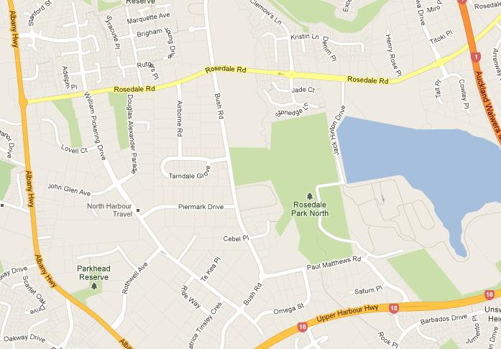

Rosedale South – attached to North Harbour Hockey

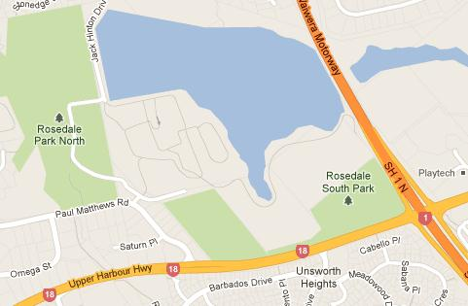

Albany Domain – Next to Albany Community Preschool

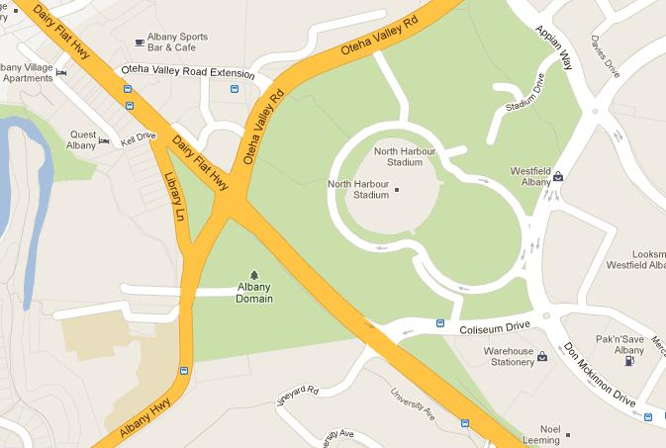

Contact information

Office Katrina Clark
Office Administrator/Secretary
Upstairs, Club Rooms
Rosedale Park
Jack Hinton Drive
Albany
PO Box 302 764, North Harbour
Ph: 4158771
Fax: 4158772
Email: admin@albanyunited.org
Website: www.albanyunited.org

