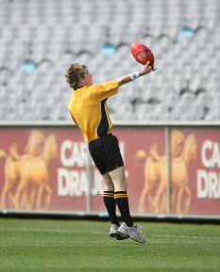
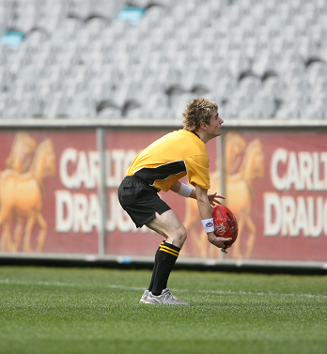
Register by Wednesday 13th February 2013:
Michael Roberts
AFL Vic Southern Region Development
Dandenong Stingrays
(03) 9791 8656
michael.roberts@aflvic.com.au
Benefits of completing this course:

• Job opportunities - pathways from volunteer to paid employment
• Become a valued member of the club
• Introductory Accreditation Certificate
• Leadership (within a club environment)
• Active engagement in activities
• The game can’t happen without umpires
Course length: 4 weeks
(Optional 5th week - Tour of a VFL Ground)
Where: Shepley Oval, Dandenong
Day: Wednesday
Commencing:
27th February - 20th March 2013
(optional 5th week - 27th March 2013)

Time: 10.30am—12pm
Cost: $30 (Inc. Course Booklets, DVDs, Bag, Drink Bottle, Wrist Bands, Whistle, BBQ and presentation of Introductory Certificate)
AFL Victoria in partnership with Access For All Abilities
are seeking male and female football fans with a mild intellectual disability
to take part in the 2013 Introductory Boundary Umpiring Course.

INTRODUCTORY BOUNDARY UMPIRE COURSE

INTRODUCTORY BOUNDARY UMPIRE COURSE
REGISTRATION FORM
Registration, Payment and Media Consent forms must be completed by Wednesday 13th February 2013 to Michael Roberts at michael.roberts@aflvic.com.au or posted to Michael Roberts P.O Box 1313 Dandenong Victoria 3175. Any questions call Michael Roberts on (03) 9791 8656.

Surname: _________________________ First Name: _________________________________
Home Address: ______________________________________________________________________
Suburb: ________________________ Post Code: ________
Telephone No: __________________ Email: _____________________________________
Date of Birth: ___/___/____ Gender: M / F
Do you:
(Please mark an X in the appropriate box)
Go to school
Go to work
Attend a day service
Other: __________________________________________________________________
What is the name of your school or day service?
____________________________________________________________________________________

Emergency Contact:
(Details of the Parents/Guardians/Carer if needed to be contacted during the course)
Name: _____________________________ Relationship: __________________________
Best Contact Numbers:
- _________________________________________

- _________________________________________
Privacy Statement: The personal information requested on this form is being collected by the AFL and AFL Victoria for record keeping and market research purposes only. This information will be used solely by the AFL and AFL Victoria for that primary purpose or directly related purposes and will not otherwise be disclosed without consent or as required or permitted by law.

INTRODUCTORY BOUNDARY UMPIRE COURSE
PAYMENT FORM
Cost of the Course: $30
Cost includes: Course Booklets, DVDs, Bag, Drink Bottle, Wrist Bands, Whistle, BBQ and presentation of Introductory Certificate
Select a payment method from the three (3) listed below by marking an X in the appropriate box.

Method 1: Direct Debit
BSB No: 083-054
Account No: 124406555
Account Name: Australian Football League (Victoria) Limited
Please put reference as FIRST INITIAL plus SURNAME plus 07-BU13 (AFL Course Coding).
For example: JBloggs07-BU13
Name of Card Holder: …………………………………………………………..
Payment on behalf of: ……………………………………… Date of payment: .……………..

Method 2: Cheque
Payable to: AFL Victoria Ltd
Post with your registration form to: Michael Roberts P.O Box 1313 Dandenong Victoria 3175
Or payable on Wednesday 27th February 2013 (first day of course)

Method 3: Cash
Cash payment accepted on Wednesday 27th February 2013 (first day of course) only. You must post your completed forms prior to Wednesday 13th February 2013

INTRODUCTORY BOUNDARY UMPIRE COURSE
MEDIA CONSENT FORM
I agree to allow AFL Victoria to use photographs and / or videos in which I am shown participating in the services it provides. This material may be used for:

Publication in newspapers Website
Community newsletters Face Book
Service brochures / promotions Twitter
Business brochures You Tube
Annual report Promotional Emails
Display Boards DVD Recording

Please specify below if you do NOT wish to provide consent for any of the above material:

Should I wish for any of the above not to be used after the date I have given my consent, I acknowledge that it will be my responsibility to inform Options Victoria of this request, in writing.

I acknowledge that it will not be possible for the service to cease publication immediately should they be in process at the date of my request.

My withdrawal of consent will cease any further printing / publication from the date of my request.
__________________________________________________________________________________

PARTICIPANTS CONSENT
CLIENT CONSENT
I agree to AFL Victoria using photos/videos of me as set out in this form. This form has been explained to me by the person whose signature appears below mine.

(Participant’s Name) ___________________________________________________

of (Address) ______________________________________________________________

Signature Date
Participant:

I acknowledge that I am signing this form on behalf and in the best interests of the person mentioned above.
Parent/Carer/Guardian:

