

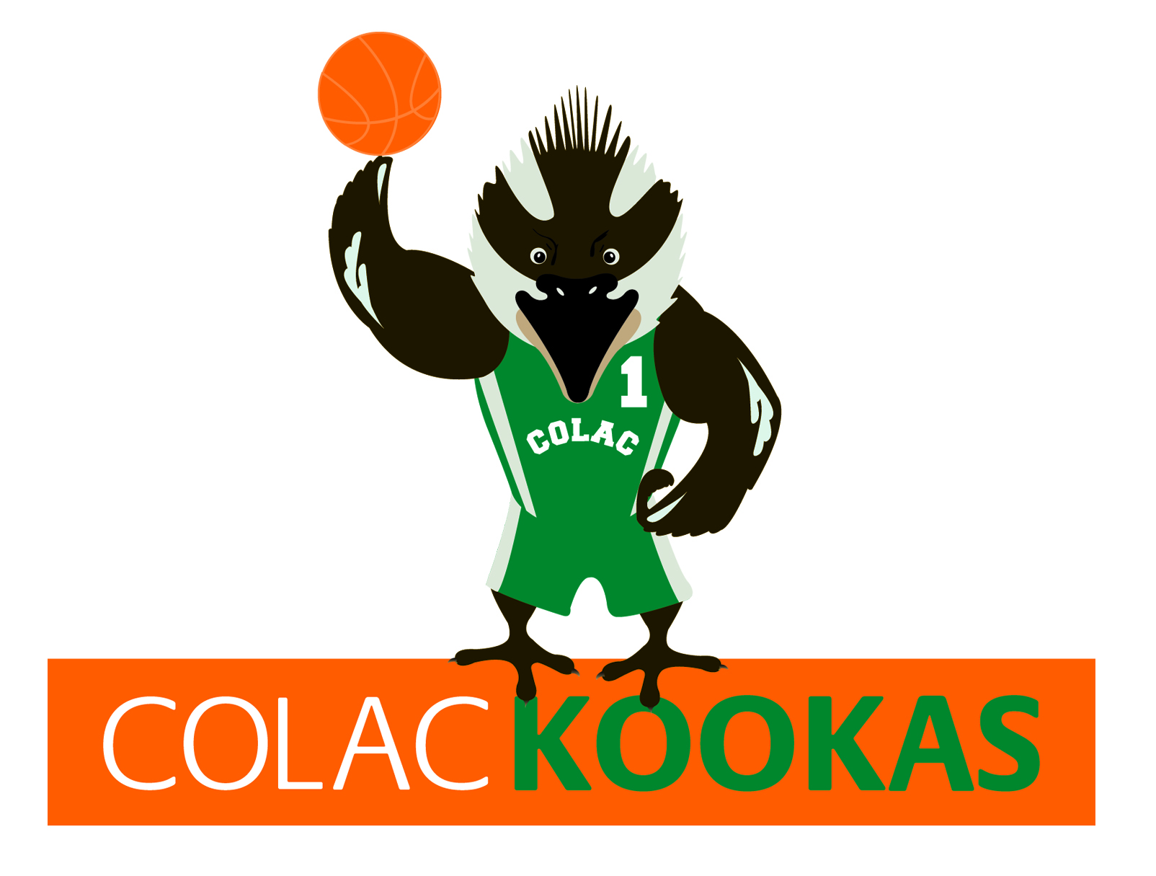

COLAC BASKETBALL ASSOCIATION

Colac Sports Power - JUNIOR TOURNAMENT 2015

Under 12 & 14’s

Tournament Dates Feb 28th and March 1st 2015

# ENTRY FORM

Please complete this form and have your association secretary sign and date the entry form.

**Entry Fee $250 per team**

Declaration forms must be mailed together with the Entry Form

Team Entries close Friday 6th February 2015

|  |  |  |  |
| --- | --- | --- | --- |
| ASSOCIATION: |  | | |
| UNIFORM/COLORS: |  |  |  |
| AGE GROUP/DIVISION |  | MOBILE: |  |
| COACH |  | MOBILE: |  |
| TEAM MANAGER |  |  |  |
| EMAIL |  | | |

|  |  |  |  |  |
| --- | --- | --- | --- | --- |
|  | Team | Under 12’s | Under 14’s | Total Teams |
|  |  |  |  |  |
|  |  |  |  |  |
|  |  |  |  |  |
|  |  |  |  |  |
|  |  |  |  |  |
|  |  |  |  |  |

SECRETARYS SIGNATURE:…………………………………DATE:……………………..

Copies of all tournament forms can be downloaded from the Colac Basketball Assoc. Website:

[www.colac.basketball.net.au](http://www.colac.basketball.net.au)





COLAC BASKETBALL ASSOCIATION

BULLA DAIRY FOODS - JUNIOR TOURNAMENT 2015

Under 12 & 14

# DECLARATION SHEET

Coaches/Team Managers: Please complete this form and have your association secretary sign and date the declaration.

Declaration forms must be mailed together with the Entry Form

Team Entries close Friday 6th February 2015

|  |  |  |  |
| --- | --- | --- | --- |
| ASSOCIATION: |  | | |
| UNIFORM/COLORS: |  |  |  |
| AGE GROUP/DIVISION |  | MOBILE: |  |
| COACH |  | MOBILE: |  |
| TEAM MANAGER |  |  |  |
| EMAIL |  | | |

|  |  |  |  |  |
| --- | --- | --- | --- | --- |
| NO. | SURNAME | GIVEN NAMES | BVCC/SA  Rego No. | D.O.B |
|  |  |  |  |  |
|  |  |  |  |  |
|  |  |  |  |  |
|  |  |  |  |  |
|  |  |  |  |  |
|  |  |  |  |  |
|  |  |  |  |  |
|  |  |  |  |  |
|  |  |  |  |  |
|  |  |  |  |  |
|  |  |  |  |  |
|  |  |  |  |  |

SECRETARYS SIGNATURE:…………………………………DATE:……………………..

Copies of all tournament forms can be downloaded from the Colac Basketball Assoc. Website:

www.colac.basketball.net.au





COLAC BASKETBALL ASSOCIATION

BULLA DAIRY FOODS - JUNIOR TOURNAMENT 2015

# REFEREE NOMINATION FORM

|  |  |  |  |
| --- | --- | --- | --- |
| ASSOCIATION/CLUB |  | | |
|  |  |  | |
| CONTACT NAME |  | PHONE: |  |
|  |  |  | |
| EMAIL: |  | | |

## **AT LEAST 1 REFEREE PER EVERY 2 TEAMS MUST BE NOMINATED**

|  |  |  |  |  |  |
| --- | --- | --- | --- | --- | --- |
| NAME | PHONE | EMAIL | TIMES AVAILABLE | CURRENT GRADING | SPECIAL REQUESTS |
|  |  |  |  |  |  |
|  |  |  |  |  |  |
|  |  |  |  |  |  |
|  |  |  |  |  |  |
|  |  |  |  |  |  |
|  |  |  |  |  |  |
|  |  |  |  |  |  |
|  |  |  |  |  |  |

### PLEASE MAIL WITH ALL OTHER FORMS BY

**FRIDAY 6TH FEBRUARY 2015**

TOURNAMENT SECRETARY

PO Box 105

COLAC 3250

Email: [colacbasketball@gmail.com](mailto:colacbasketball@gmail.com)

**2015 TOURNAMENT RULES**



**TIMING REGULATIONS:**

* Preliminary and Semi-Final Games: 2x20 minute halves.
* 2 time outs per half. CLOCK DOES NOT STOP 1st half
* No time outs last 2 minutes of 1st half. Clock stops for all whistles in the last minute of the 2nd half
* Half time break: 2 minutes
* Grand Final: As per above except CLOCK STOPS FOR ALL WHISTLES in the last minute of the 1st half and all whistles in the last 3 minutes of 2nd half.

**ELIGIBILITY FOR FINALS**

Player must play in one preliminary round and only play in one team, otherwise matches will be forfeited in which that player takes part

**RULES**

1. All players must be the correct age as at 31/12/15.

2. All games are to commence at the advertised starting time.

3. Scoresheets are to be completed 15 minutes before games commencement.

4. No team shall take the court with less than 5 players. Penalty 1 point for every minute that such team is unable to take the court

5. If a team is 10 minutes late this constitutes a walk over.

6. Teams must supply a **competent** scorer/time keeper.

7. Teams must supply their own warm up ball. Game ball to be selected from the 2. Under 16 & 18 boys size 7 all other divisions size 6.

8. As per BVCC guidelines all under 12 and 14 teams are to play MAN to MAN DEFENCE. All other age groups are encouraged to play man to man defence.

9. Any protests or disputes to be referred to the Tournament Administrator within one hour of the completed game.

10. Any player being reported, must report to the Referee’s Supervisor at the venue, and then must appear before the nominated Tournament Tribunal prior to their next scheduled game.

11. Entries accepted on first in – first accepted.

12. BVCC heat policy will apply if the court temperature reaches 35 degrees.

13. The Committee’s decision on any matter is final.

14. There will be no refund of fees if a team withdraws after the draw is completed.

15. All teams are to supply their own FIRST AID needs. Ice will be available at all venues.

16. The 3 point rule will not apply in Under 12, but will apply for the Under 14 and Under 16 competitions.

17. 3.7 meter foul line will be used in under 12 games.

**POINTS**

1. Games points – Win = 3 Draw = 2 Loss 0 Bye = 3

Forfeit given = 0 Forfeit received = 3

2. Drawn games will remain in preliminaries, extra 5 minutes played in finals.

3. 3 way ties, best % of teams involved in games played against each other.

4. 2 way tie decided by preliminary round head to head. If drawn game, decided on %.

**UNIFORM**

1. Each team will nominate its uniform and players will not be permitted to take the court if not properly attired in nominated uniform.

2. Shoes which mark the player surface must not be worn.

3. Each team must have an alternate top. If there is a clash of colours, the 2nd nominated team will be required to change their top.

4. A team not providing alternate tops may incur a fine.

**The Colac Basketball Association deny any liability for any injury sustained by any person during the Tournament.**