**2012**

**Yearbook**

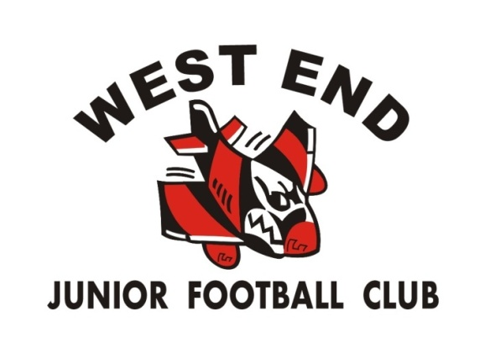











[***http://westendjfc.vcfl.com.au***](http://westendjfc.vcfl.com.au)

fACEBOOK LOGO.png



Sponsored by:

******West End Life Members**  
Pat O’Brien 1990

Sharyn Meiracker 1996

John Meiracker 1996

Don Frankland 1999

Glen Setches 2003

# Shane Griffiths 2008

# West End JFC 2012 - Club Sponsors

***BRANSTRANS PTY LTD***

**VIC HEALTH & LATROBE CITY COUNCIL**

RGM ACCOUNTANTS, GIPPSPRINT & THE GOOD GUYS TRARALGON

LATROBE FIRST NATIONAL & DEERINGS SELECTION CENTRE

DAHLSENS & COLES

## Award Sponsors

.... Domino’s Pizza.....Souvlaki Hut.....

Video Ezy...... McDonalds Traralgon..... Morwell Ten Pin Bowling

......Subway..... The Fun Shack..... Stockland Plaza

# Presidents Report 2012

On the field

U10’s had another great season finishing fourth on the ladder and in the end eliminated in the first week of the finals. This was a great result from a very enthusiastic group of players and gives us plenty of promise for future years. Well done to coach Sid Hourigan and all the helpers.U12’s had an up and down year and at the end of the home and away season finishing 6th on the ladder. The team had an unlucky run with injuries keeping key players off the field that impacted on our overall result. Well done to Clinton Rodda in his first year as coach.

U14’s was a very even competition this year and teams had to play well on the day to win. The U14 team put some great games and ended up 6th on the ladder. Peter Barry was seen “blowing his fuse” a few times but managed to keep it together and had another great year as coach.

U16’s - In season 2012 there was no U16 team. Sharleen Barry tried to get the team together but couldn’t get the numbers. Sharleen took care in ensuring players had a club to go to and no one was left out in the cold. In 2013 we hope to see the players “on loan” to other clubs return home and we’ll have an U16 team.

Individual player achievements

Many players polled votes in the league best and fairest but no award winners this year. Several players represented the TDJFL in interleague games and the club is proud of their efforts.

Helpers, volunteers and supporters.

Thank you to the various people involved in fund raising, banner making, BBQ’s, gate duty, goal umpiring, bringing lollies and oranges, time keeper – your effort is appreciated.

A special thanks to those that helped with the Bunning BBQ fundraiser.

Team staff

Thank you and well done on a great season to those directly involved with the teams:-

U10 - Coach Sid Hourigan, Team manager Mandie Hourigan, Support staff doing various roles - Greg Lawrence, Brendan Peavey, Jamie Tactor, Martin Poel, Aaron Murdoch, David Nancarrow, Chris Wood and Gail Phelan. Great to see so many people helping out!

U12 – Coach Clinton Rodda, Assistant Coach Irwin Rodda, Team manager Ken Groves, Runners Adam Lambert and Steve Riley, Support Staff Daniel Hawke.

U14 - Coach Peter Barry, Team manager Sharleen Barry, Runner Cameron Draper and Alma Patton

Committee

2012 Committee

The committee has had another busy year and a big thank you to the following people:-

Dave Catherwood (Vice-President), Sharleen Barry (Secretary, league delegate, website coordinator), Garry Williams (Treasurer), Joanne McGregor (Merchandise), David Hinde (Committee member and facilities), Paula Williams (Canteen co-ordiantor), Kylie Tactor (Registar), Chris & Sylvia Wood (Grants), Jamie Tactor (committee member) and Beverly Pead (committee member).

Committee “shake up”

The July committee meeting at the Traralgon RSL was punctuated by magnitude 5.3 earthquake that was centred on Thorpdale. The president was seen dashing toward the emergency exit while other sat calmly – not want to spill the drinks they just purchased. Let’s hope we see such a poor performance from the president again!

Committee members finishing in 2012

Garry Williams (Treasurer) and Sharleen Barry (Secretary) will finish their roles this year. These two have been the glue that kept the club going over the last few years. Thank you Sharleen and Gary.

New committee members

All parents MUST get involved with the running of the club and play their part in the “team”. Please remember that everyone on the committee is a volunteer and has similar commitments to you. If we can spread the load it makes it easier on all.

2013 season

I look forward to 2013 and we are well positioned for a good year on the field. The club will celebrate its 30th anniversary so let’s make it a special year. Enjoy your summer break from football and I look forward to seeing everyone around the grounds in 2013.

Adam Lambert

President

# 

# Treasurer’s Report 2012

The year started with the Club in an excellent financial position having cash at bank of $13,827.92, made up of $8,031.35 in our cheque account and $5,796.57 in a term deposit; with no outstanding debts. With this taken into account, the Committee was pleased that for the fourth year in succession, we saw no need to increase our player registration fees.

With regard to T.&.D.J.F. Affiliation Fees. In 2011 fees were set at $900.00 per team payable by round 7, with all clubs receiving a share of canteen profits at season’s end. Under this system the T.&.D.J.F.L. was extremely close to being required to register for GST purposes. It was proposed by the previous League Treasurer and agreed by the Clubs, that this be scrapped thus taking approximately $30,000.00 from League revenue for GST reporting purposes. In its place, Clubs would only be invoiced at season’s end (Affiliation Fee per team less Canteen profit per team); which is likely to be in the region of $250.00 per team. Actual costs to Clubs over the season remain the same.

With us not having an U/16 team this season, total revenue for player registration was well down, however this was offset by not having to pay team affiliation/insurance to both V.C.F.L. & T.&.D.J.F.L. as well as football and 1st aid equipment. The Committee hopes this situation never arises again.

A big thank-you to our sponsors, especially Rosie and the gang at Branstrans, our major sponsor, for the unwavering support; as well as Latrobe City Council, Latrobe First National, Deerings, Dahlsens, RMB Accountants, KB Living, plus all our award sponsors.

Thanks also to our own Brendon (BJ) Goddard from the St.Kilda Football Club who won $1,000.00 for us on Channel 9’s Footy Show, as well as another $1,000.00 from the NAB Honesty Challenge on Channel 7. May BJ play on for many more seasons!

To all who helped at our Bunnings BBQ, a massive thanks. $558.13 was raised on the day which was down on last year due to our day rostered and the fact that there was no Bunnings Traralgon last year. A pleasing result nonetheless.

To Jo McGregor my congratulations on a super job in arranging the Club merchandise. To see parents and players decked out in West End coats, hoodies and polo shirts makes us look a professional unit. Whilst this was not a fundraiser as such (prices marked up to the nearest $5 amount above cost), every little bit helps.

To Melanie Williams thank you very much for your fundraising efforts with the Player Poster, they looked great.

A couple of parents, Sylvia and Chris Wood, who quietly behind the scenes, did a great job for the club with their major win being a grant from VicHealth for $2,240.00; to upgrade our 1st aid equipment, gear and other assorted items. A big thank you to you both for your contribution over the season.

Major expenses over the year included our part of the storage shed (with T.&.D.J.F.L. and Traralgon Harriers), which was primarily covered by a grant from Latrobe City Council. Other expenses include V.C.F.L. registration and insurance; as well as everyday things like footballs, first aid equipment, PVC tape, crepe paper, stationary, water bottles, etc. etc. Too many to name, please see me if any queries.

It is pleasing to say that after all this; the Club is in a financial position the envy of most other Clubs in the League. With a cash at bank of $18,169.31, made up of $8,169.31 in our cheque account and $10,000 in the Term Deposit account.

And finally to Sharleen; your tireless work over numerous seasons deserves the highest praise possible. But the ultimate “baby” was to get our storage shed built, which has finally occurred. A place to store all our gear and we will get that “Trophy Wall” done.

Gary W illiams

Treasurer.

# U10’s Coaching Staff and Team Photo

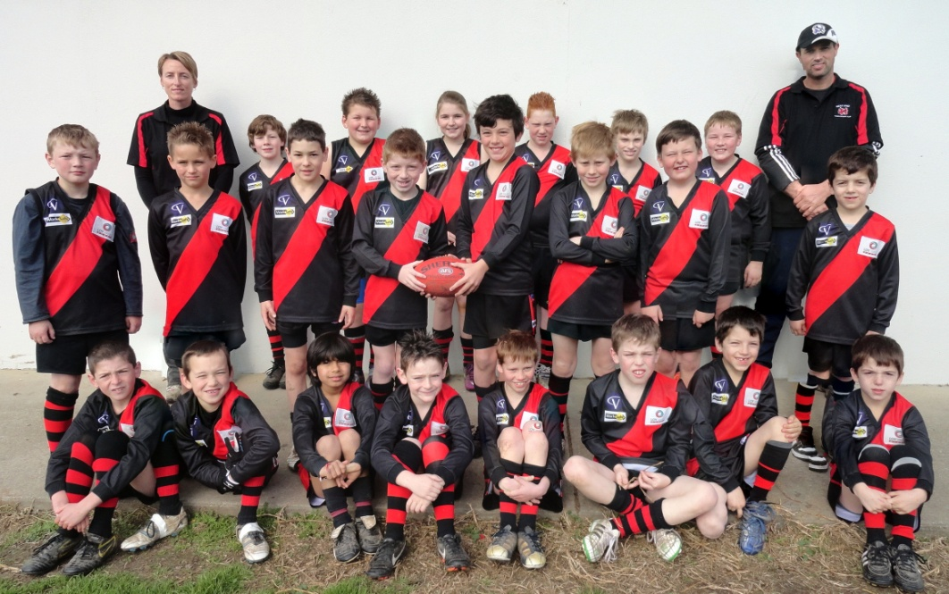

**WEST END JUNIOR FOOTBALL CLUB**

**2012- UNDER 10s**

**Back Row**: Ryan Wilson, Colby Kennedy, Kayla Kennedy, Jye Tactor, Lincoln Pead, Brad Hourigan.

**Middle Row**: Blake Jenkins, Luke McGregor, Joey Rodda, Joshua Wardle, Gabriel Wood, Riley Murdoch, Rhys McGregor, Erim Kocaali.

**Front Row**: Brady Poel, Campbell Peavey, Kishen Parekh, Jack Nancarrow, Zach Murdoch, Jack Murray, Eray Kocaali, Emre Kocaali.

Absent: Greg Lawrence (Asst. Coach), Aiden Robinson

# U10’s – Team Season Report

Coach: Sid Hourigan

Assistant Coach: Greg Lawrence

Team Manager: Mandie Hourigan

Captain: Josh Wardle

Vice Captain: Gabriel Wood

**U10’s – Team Season Report**

Another great season had by our U/10’s in 2012. To start the season we had 13 brand new players, so the season was going to be a bit of the unknown.

The lads (& lass) trained well in pre-season and showed some encouraging signs. Our team played well in some tough footy conditions this season. The cold and wet, the water and mud; it was all thrown at them. But to their credit they took it all in their stride and played some good footy throughout the season. To finish fourth on the ladder was an awesome effort and the kids should be very proud!

A big thank you to the Greg Lawrence, Brendan Peavey, Jamie Tactor, Martin Poel, Aaron Murdoch, Chris Wood and David Nancarrow for all the work they put in behind the scenes either at training or on game day. Your help was fantastic and very much appreciated.

It has been a fun year coaching the U/10’s as the kids and parents have such great attitudes. I thank everyone for their help and friendliness throughout the season. I also wish the boys and Kayla all the best for next season, either fronting up again in U/10’s or having a crack at U/12’s.

Sid Hourigan

Coach

## West End JFC Under 10’s End of Season Club Awards

**Best & Fairest:** Josh Wardle & Riley Murdoch

**2nd Best & Fairest Runner Up:** Luke McGregor

**Most Disciplined**

(Sponsored by Branstrans P/L): Brody Deering

**Most Determined**

(Sponsored by Branstrans P/L): Joey Rodda

**Most Consistent**: Colby Kennedy

**Quiet Achiever**

Sponsored by RSL): Brady Poel

**Best Clubman**

(Sponsored by Apex): Gabriel Wood

**Good Guys Award**: Jye Tactor

**Under 10’s President’s Award Josh Wardle**

Joshua Wardle is a quiet boy who goes about his football with great enthusiasm and leads by example. He always listens and follows instructions well. He is a fair and team orientated player who treats his team mates and coaches respectfully. It was an absolute pleasure to have Josh in our team. We wish Josh the very best in his football career.

# U12’s Coaching Staff and Team Photo

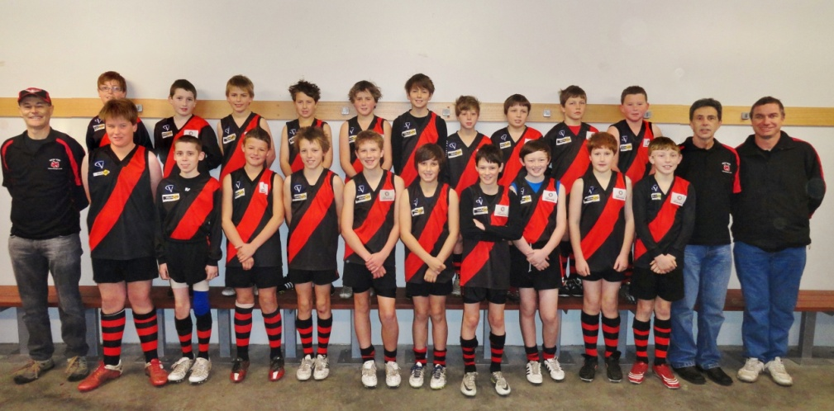

**WEST END JUNIOR FOOTBALL CLUB**

**2012 - UNDER 12s**

**Front Row**: Clinton Rodda (Coach), Dean Ravenhall, Cody Cumming, Will Ryan (Vice-Captain), Tye Hourigan (Vice-Captain), Jai Slaby (Captain), Nik Kyriacou (Vice-Captain), Linus Rodda (Vice-Captain), Brodie Tipping, Mason Riley, Riley Jenkins, Irwin Rodda (Asst. Coach), Ken Groves (Team Manager)

**Back Row**: Brody Goodwin, Zac Hawke, Brendan Orr, Aaron Hinde, Jacob Ryan, Thomas Webster, Matt O’Neill, Jake Groves, Jacob Lambert, Chad Hall

# 

# U12’s – Team Season Report

**Coach**: Clinton Rodda

**Assistant Coach:** Irwin Rodda

**Water Carrier**: Adam Lambert & Steve Riley

**Team Manager**: Ken Groves

**Captain**: Jai Slaby

**Vice Captains**: Tye Hourigan, Linus Rodda,

Nik Kryiacou, Will Ryan

**U12’s – Team Season Report**

We were excited to be given the opportunity to coach just a few weeks out from the season. We started with about 15 boys but by Lightning Premiership we had 18 and then 20 from the season proper.

The boys tackled pre-season training with enthusiasm. After getting the views of the boys, Jai Slaby was appointed captain with Tye Hourigan, Linus Rodda and Nik Kyriacou as vice captains. Unfortunately, Jai fractured a finger before Lightning Premiership. We used the games to try players in different positions around the ground. Our 3 games were a reality check with 3 losses in the 3 games – but a great experience for our ex U10’s and new boys seeing what the pressure of U12 games was like.

While Jai was still missing, the boys were excited about round 1 and we had a good battle with TEDAS, kicking 3 goals but going down by about 40 points. After a frustrating forfeit by Cumberland park we tackled top side, Police Boys and held them to 7 goals. After a bye, round 5 saw our first win against Glengarry by 41 points – a real 4 quarter effort which gave the boys confidence. Round 6 saw us take on Combined Saints at Stoddart. The big ground was a new experience for the boys and the game was called at ¾ time.

Another injury blow saw us lose Tye for the next couple of games however the leadership and performance of Will Ryan in the first few rounds of the season saw him elevated to a vice captain role. While we tried hard, losses to Pax Hill and TEDAS followed. Round 9 saw our next win against Cumberland Park – having the game called at ¾ time with some the teamwork we were working on at training really showing out. We were competitive against Southside in the next game kicking 3 goals but going down in another good effort.

After the next bye, we again took on second side Police boys, this time reducing their scoring shots from 15 to 14 and increasing ours from 0 to 4. It was clear that a lot of boys were getting more confident and really improving. Round 13 saw us take on Churchill and have our best win for the year by 30 points. After a tight tussle, we broke away late in the second quarter and never looked back – playing with the fluency and teamwork we focused on all season. Unfortunately, we lost Jai and Zac for the last game against Combined Saints but even without them we were really competitive with several boys having their best games of the year.

What satisfied Irwin and I most was the really positive attitude and behaviour of the kids all year. We had a lot of fun and all kids and the team improved over the year.

Thanks to Ken and Janine for their great work as Team Managers, Adam and Steve as runners, Daniel and Chrissy for helping out at training and all the parents for their support. West End is a great club and relies on a dedicated committee and volunteers to make it work.

Clinton and Irwin Rodda

Coaches U12’s

## West End JFC under 12’s End of Season Club Awards

**Best & Fairest:** Tye Hourigan

**Best & Fairest Runner Up:** Jai Slaby

**Best Utility:** Will Ryan

**Most Disciplined**

(Sponsored by Branstrans P/L): Mason Riley

**Most Determined**

(Sponsored by Branstrans P/L): Nik Kyriacou

**Most Consistent**: Linus Rodda

**Quiet Achiever**

Sponsored by RSL): Jake Groves

**Best Clubman**

(Sponsored by Apex): Jacob Ryan

**Good Guys Award*:*** Zac Hawke

**Under 12’s President’s Award: Tye Hourigan**

# Congratulations to all boys on their season including the Award Winners.  Our President’s Award this season goes to Tye Hourigan.  Tye has been with the club for four seasons and this season demonstrated outstanding leadership skills, behaviour and commitment to the team.  He leads by example by throwing himself into every activity at training, demonstrating a positive attitude towards coaches, officials and his team mates as well as a great work ethic on the field.  He was a standout from several players who would have been worthy winnersU14’s Coaching Staff and Team Photo

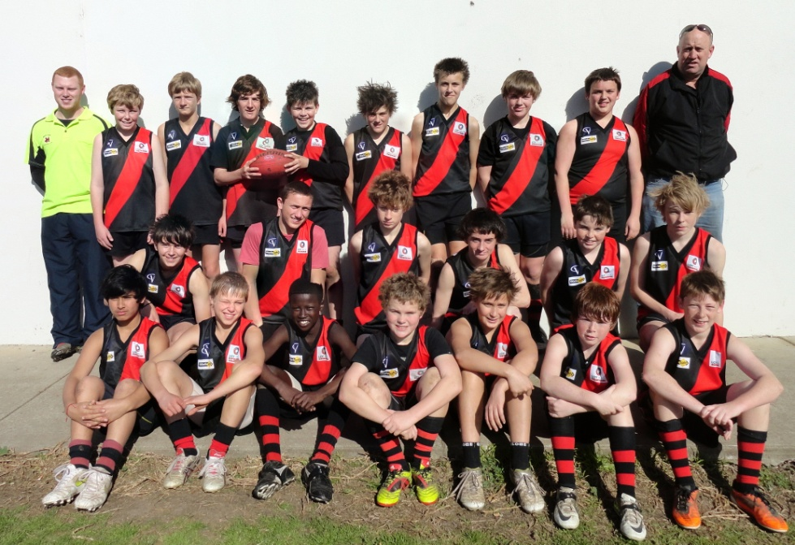

**WEST END JUNIOR FOOTBALL CLUB**

**2012 - UNDER 14s**

**Front Row**: Abhishek Parehk, Jordan McGregor, Ajith Aciek, Nic Stevenson, Josh Newnham, Billy Ollier, Levi Bailey

**Middle Row**: Josh Moore (Vice-Captain), Jacob Peterson, Ben Jones, Aiden Danvers, Conor Williams, Jack Curley

**Back Row**: Cameron Draper (Runner), Luke Miller, Daniel Galea-Bransgrove, Jake Sands (Captain), Liam Barry (Captain), Michael Ryan, Jack Strong, Matt Williams, Mitch Kavadias, Peter Barry (Coach)

**Absent**: Sharleen Barry (Team Manager)

# U14’s – Team Season Report

**Coach**: Peter Barry

**Team Manager**: Sharleen Barry

**Runner**: Cameron Draper

**Captain**: Jake Sands & Liam Barry

**Vice- Captain**: Josh Moore

**U14’s – Team Season Report**

This season started off differently to any other year that I have coached. With low numbers, new players arriving and having to teach the existing and the new players how to play as a team whilst trying to develop the individual players needs and skill / abilities was challenging. Once some issues were sorted out early, the team knew what we were about, the side become more confident within themselves and as a team and showed real improvement. Over the season we ended up with 2 byes which takes some getting use too, especially when trying to develop a side and make into the top 4 on the ladder. In the end, we weren’t quite not good enough to finish in the 4 but made the opposition earn their way.

I would like to thank ALL of the players for being able to withstand the hard arse way in which I have coached this season and if I have offended any of you I apologise. The reason for pushing some of you guys, is for you to work harder at your football and to believe in yourselves. What I see on the side lines are guys that have great potential but you just don’t realise yourselves, so once again sorry. I would like to especially thank Cameron for his commitment again this season, having to play the role of the Runner/Water boy /Assistant Coach without his dedication, things would have been a lot harder for myself.

I would also like to thank my Team Manager Sharleen for another season of good work and for putting up with myself once again, to Alma thank you for another solid season helping not just on game day but behind the scenes, to all the parent that goal umpired and were timekeepers thank you guys also.

At the start of the season league rules were changed so top aged players could play up an age group, this worked out to be a handy rule for us during the season when we were unable to field 18 players. This happened twice during the season which gave Jai Slaby & Will Ryan from Under 12’s an opportunity to play in Under 14’s. Both boys adapted to the speed of the game very well and to both boys thank you very much and all the best for next season.

In closing I would just like to thank the West End Football Club, Committee, parents and players for allowing me to coach at the club. I would like to wish the Club and all involved the best for the future. It has been a journey that I won’t forget. Thanks again for everyone’s support it has been greatly appreciated.

Peter Barry

Coach

## 

## West End JFC Under 14’s End of Season Club Awards

**Best & Fairest**

**( Brendon Goddard Trophy): Matt Williams**

**Best & Fairest Runner Up: Michael Ryan**

**Best Utility:**

(Sponsored by Branstrans P/L): **Jacob Peterson**

**Most Determined**

(Sponsored by Branstrans P/L): **Josh Moore**

**Most Improved: Nic Stevenson**

**Quiet Achiever**

Sponsored by RSL): **Conor Williams**

**Best Clubman**

(Sponsored by Apex): **Liam Barry**

**Good Guys Award: Daniel Galea-Bransgrove**

**Under 14’s President’s Award: Michael Ryan**

Over the years I have watch Michael play football and develop from a child to a teenager. He has always been a polite person in every way. Coaching him this season showed me how mature and dedicated to his football he had become. It didn’t matter if he wasn’t feeling the best with the flu or had a niggling injury he was always at training, willing to assist with drills or help others one on one. Come game day Michael gave 100% on the field, for this alone I believe Michael deserves this award. Michael was the only U14 player from West End to make the Interleague team this season, well done. Congratulations Michael on winning this award and all the best for your future on and off the field.

# 50 & 100 Game Information

## 50 Games

Those players who celebrated 50 games of junior football in Season 2012 were:-

**Under 12’s** – Linus Rodda, Jacob Lambert, Tye Hourigan, Thomas Webster, Jacob Ryan

**Under 14’s –** Mitchell Kavadias

## 100 Games

In Season 2012 the following boys played 100 games of junior football:-

**Under 14’s –** Liam Barry & Jake Sands

# 2012 Interleague

**Four players from West End** were selected to represent Traralgon in the Annual Interleague carnival held in Sale and Stratford.

**Congratulations to the following players**:-

**U/12’s** – Jai Slaby, Will Ryan & Tye Hourigan

**U/14’s** – Michael Ryan

## Best Club Person Award

Nominations for the Best Club Person Award received from committee members and coaching staff were:-

Cameron Draper

Greg Lawrence

Irwin Rodda

Daniel Hawke

Alma Patton

The Best Club Person for 2012 was awarded to Cameron Draper. Cameron doesn’t have any children involved with the Club and has assisted Peter Barry with the Under 12’s in 2011 and Under 14’s in 2012, as the Runner/Assistant Coach. Cameron has shown commitment and dedication to the West End JFC which has been greatly appreciated by all.

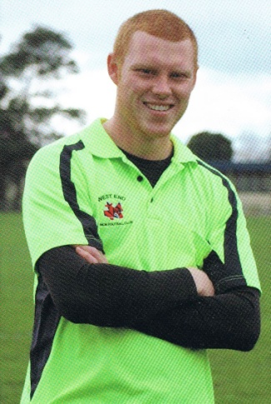

# *2012 League Best & Fairest Winners*

**Under 10’s –** Beau Hutton – Police Boys

**Under 12’s –** Jordan Jobling – Police Boys

**Under 14’s –** Kade Duncan – Tedas

**Under 16’s –** Connor Sloyan – Combined Saints

**Jason Boulton Memorial U14 Goal Kicking Award –** Luke DiCierio

**Chris Zotti Memorial U16 Goal Kicking Award –** Jarryd Garlick

**Code of Conduct Award -** Glengarry

## League Goalkicking Ladders

## Top Goal Kickers U14’s

1. Luke DiCerio - Southside 39

2. Brock Thompson – Combined Saints 38

3. Josh Heard - Tedas 30

4. Kade Duncan – Tedas 27

5. Riley Livingstone - Southside 27

6. Bailey Charalambous – GlenPark 23

*7. Jacob Peterson – West End 19*

# 

# End of Season Ladder Details 2012

## U12’s Ladder Results

**CLUB POINTS**

Police Boys 52

Combined Saints 48

Pax Hill 44

Southside 40

Tedas 28

*West End 24*

Churchill 20

Glengarry 20

Cumberland Park 4

## U10’s Ladder Results

**CLUB POINTS**

Police Boys56

Pax Hill 52

Tedas 44

*West End* *40*

Combined Saints 32

Glengarry 28

Southside 28

Cumberland Park 20

City Juniors 16

Churchill 12

Boolarra 8

## U14’s Ladder Results

**CLUB POINTS**

Southside 48

Combined Saints 46

Tedas 44

Police Boys 36

GlenPark 34

***West End 28***

Pax Hill 20

City Juniors 12

Churchill 12

# The 2012 West End J.F.C Committee

|  |  |
| --- | --- |
| Adam Lambert  President  DSCF1048.JPG | Gary Williams  Treasurer  024 (3) |
| Dave Catherwood  Vice President  RIMG0044  **GENERAL COMMITTEE**:  Paula Williams (Canteen Co-Ordinator & Sponsorship),  Kylie Tactor (Registrar), Jamie Tactor,  David Hinde (Risk Assessment Officer & Ground Management),  Chris & Sylvia Wood (Grants Officers),  Joanne McGregor (Merchandise), Beverly Pead (Facebook) | Sharleen Barry  Secretary  Committee 002 |
|  |  |



Proudly Sponsored by: