School Holiday Basketball Camp! For boys and
Girls aged 5-12.
10am – 3pm
Wednesday 9th April 2014
Thursday 10th April 2014

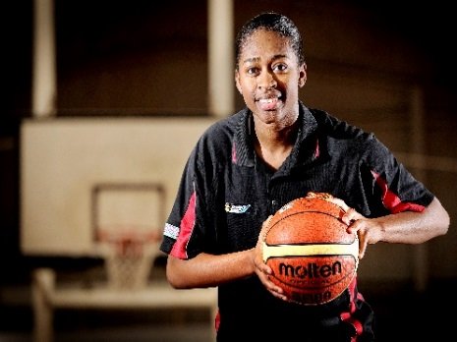

…………………………………………………………………………………………………………………………………………………………….

Please detach and return this form to the Mildura Basketball Association office with
payment of $90.00

Childs Name:………………………………………………. Age…………..D.O.B………………M/F........
Address…………………………………………..Town……………………………P/C……
Parents name……………………………………
HomeP/h…………………………… Mobile:……………………………………
Email:………………………………………
Emergency Contact:……………………………Phone:…………………………………..
Does your child have any medical conditions we should know about? Yes / No Condition………………………………………………
Ambulance Subscription Number………………………………..

In case of an emergency do you authorize the Mildura Basketball Association to arrange the necessary medical treatment for your
child Y/N

I give permission for my child’s photo to be taken during an any promotional activities which may be undertaken by the Mildura
Basketball Association during the two days of the School Holiday Basketball Camp.

Signed:………………………………………………………………………………. Date:…………………………………………………..

