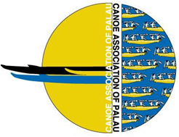
2013 Micronesia Cup, Palau
“International Outrigger Canoe Race”
October 25-26 (Friday to Sunday)
Venue in Koror @Meyuns Ramp

EVENTS INFORMATION

FEES PER CREW OF 9 PADDLERS
$350.00US DOLLARS (Event Shirt, opening and closing dinner)

CATEGORIES EVENTS
Open Men 500M SPRINT
Open Women 1500M SPRINT
Mix Open LONGDISTANCE
Mix Juniors (11 to 19yrs.) 20km Miles Open Men
15km Miles Open Women
15km Miles Mix Masters
10km Miles Mix Juniors

DATE EVENTS
Friday 25th October LONGDISTANCE Course TOUR Friday 25th October TEAM BRIEFING AND DINNER

Saturday 26th October SPRINTS ALL DAY & LD Tour
Sunday 27th October LONGDISTANCE
Sunday Night Closing Ceremony and Dinner

Tournament Organizers and Contacts
Alonz Moses, Tournament Director, Baklai Temengil, Race Secretary
And Debbie Toribiong , Race Coordinator
Contacts: Alonz 779-7754 . Baklai 775-6662 . Debbie 778-6466
pnoc@palaunet.com

