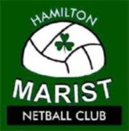

Coach needed
Verdettes-Marist Premier Reserve Team

Expressions of interest are now invited for the coaching position of the
Verdettes-Marist Premier Reserve Team.

Please submit your expression of interest with a brief record of your experience by
Monday 12th January 2015

Verdettes Secretary Email: smswater55@gmail.com or phone 0274 390901
Marist President Email: maristnetballhamilton@gmail.com or phone 021 2499267

Interviews to be held the week of Monday 19th January 2015

